**Name: Sureshkumar V P**

**Company: MSG Global Solutions India Private Limited**

**Country:** **India**

**ASSIGNMENT**

**EU COUNTRY NAMES - TOP 3 HIGHEST STANDARD & TOP 3 LOWEST REDUCED VAT RATES**

**09-12-2022**

**Objective**

Build a microservice which exposes a REST API for:

• Return three EU countries with the highest standard VAT rate

• Return three EU countries with the lowest reduced VAT rates

Input: [https://euvatrates.com/rates.json](https://eur03.safelinks.protection.outlook.com/?url=https%3A%2F%2Feuvatrates.com%2Frates.json&data=05%7C01%7C%7C291163ebb0834e1093ee08dad697583a%7Cc2350a4a56c64ec19195e636c90735d6%7C0%7C0%7C638058242808176820%7CUnknown%7CTWFpbGZsb3d8eyJWIjoiMC4wLjAwMDAiLCJQIjoiV2luMzIiLCJBTiI6Ik1haWwiLCJXVCI6Mn0%3D%7C3000%7C%7C%7C&sdata=Nqx2a3rDR3E0nwY%2FOKMsH0gfzG2BFNE5tS1MowXBdy8%3D&reserved=0)

**High Level Diagram**

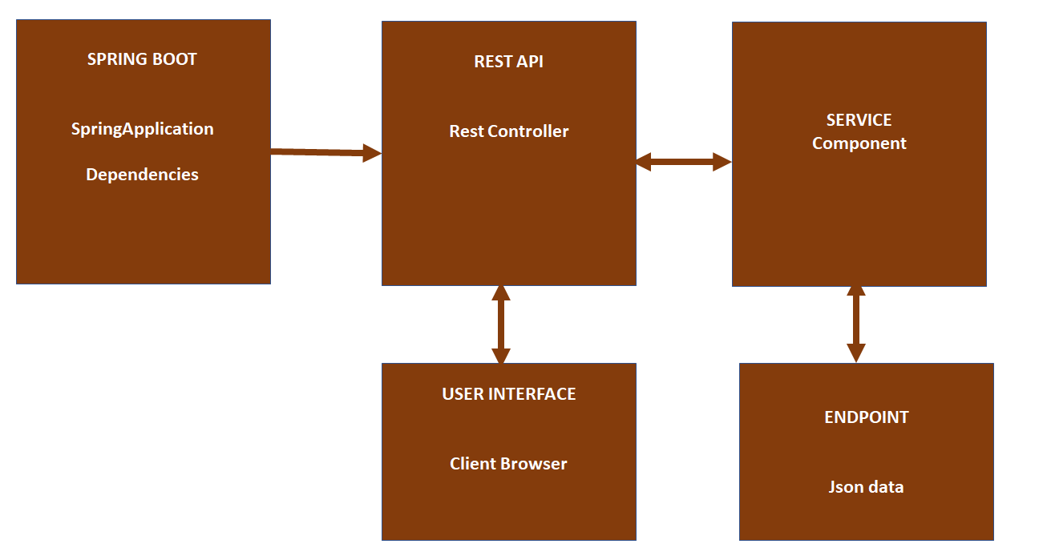

**Class Diagram**

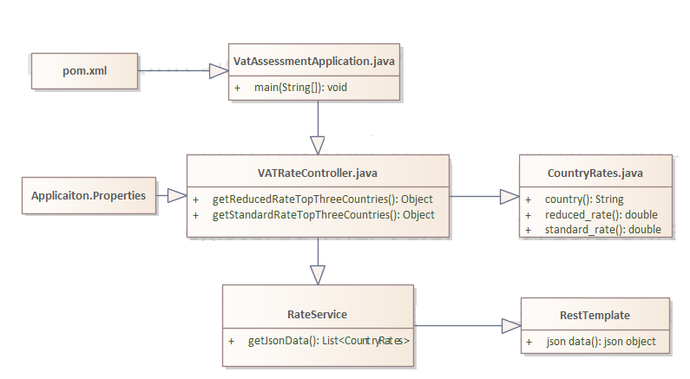

**Sequential Diagram**

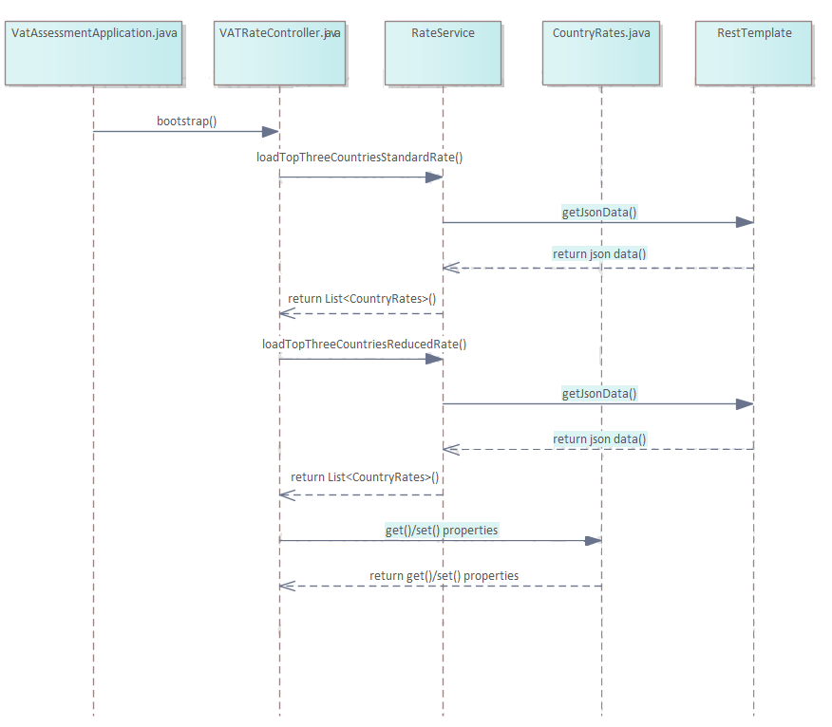

**Test Results**

* **Input:** [https://euvatrates.com/rates.json](https://eur03.safelinks.protection.outlook.com/?url=https%3A%2F%2Feuvatrates.com%2Frates.json&data=05%7C01%7C%7C291163ebb0834e1093ee08dad697583a%7Cc2350a4a56c64ec19195e636c90735d6%7C0%7C0%7C638058242808176820%7CUnknown%7CTWFpbGZsb3d8eyJWIjoiMC4wLjAwMDAiLCJQIjoiV2luMzIiLCJBTiI6Ik1haWwiLCJXVCI6Mn0%3D%7C3000%7C%7C%7C&sdata=Nqx2a3rDR3E0nwY%2FOKMsH0gfzG2BFNE5tS1MowXBdy8%3D&reserved=0)



* Return three EU countries with the highest standard VAT rate

**Output URL:** [**http://localhost:8080/api/vat/getStandardRates**](http://localhost:8080/api/vat/getStandardRates)

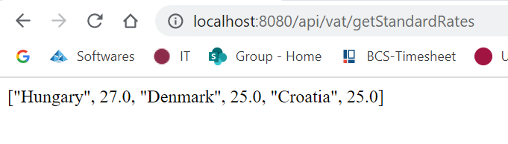

* Return three EU countries with the lowest reduced VAT rates

**Output URL:** [**http://localhost:8080/api/vat/getReducedRates**](http://localhost:8080/api/vat/getReducedRates)

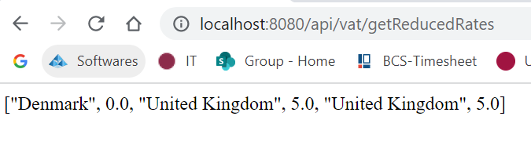

**Steps to configure and execute (in eclipse ide)**

1. Download archive file (vat_assessment.7z) from one drive (link shared via email) and extract into local folder
2. Open eclipse tool
   1. File and select import as Maven project by choosing the extracted project folder

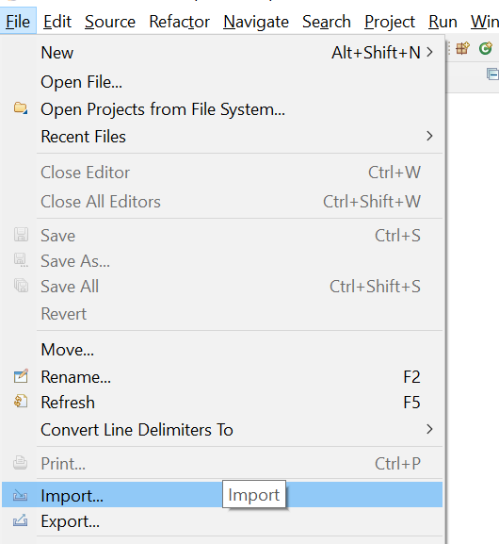

* 1. Select Existing Maven Projects

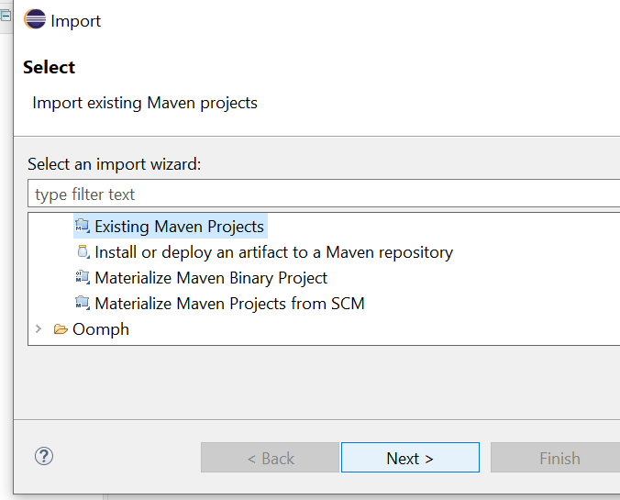

* 1. Select Root directory of the project extracted and select pom.xml check box and Finish

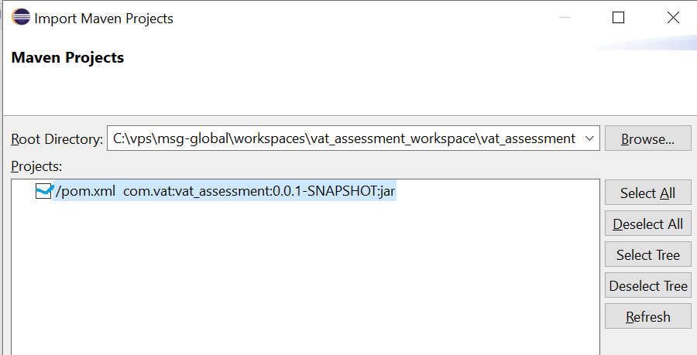

1. Update maven by selecting the project

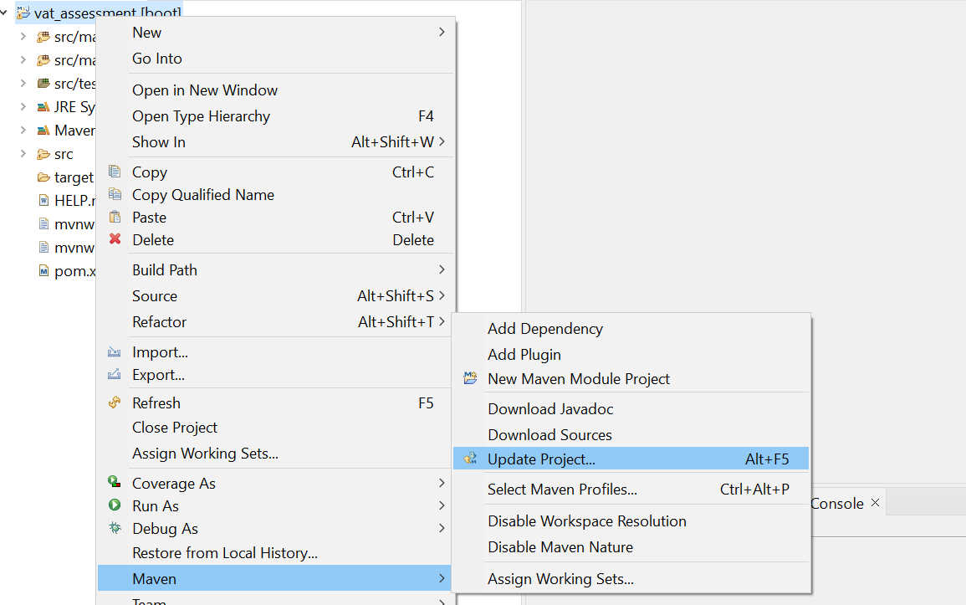

1. Select VatAssessmentApplication.java and click Run as Java Application

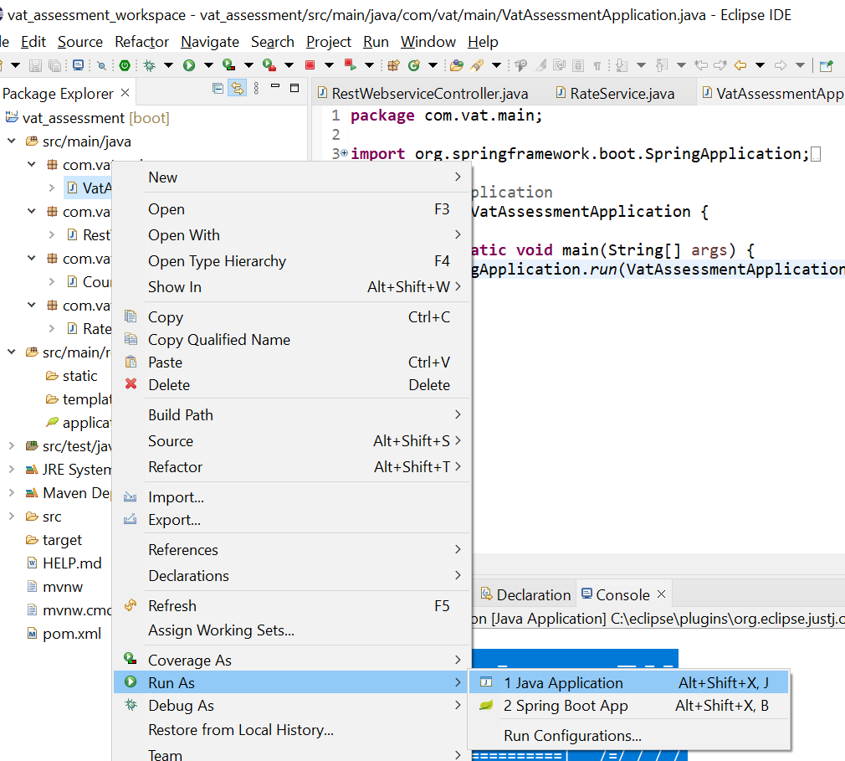

1. Once Spring Boot started by confirming in console

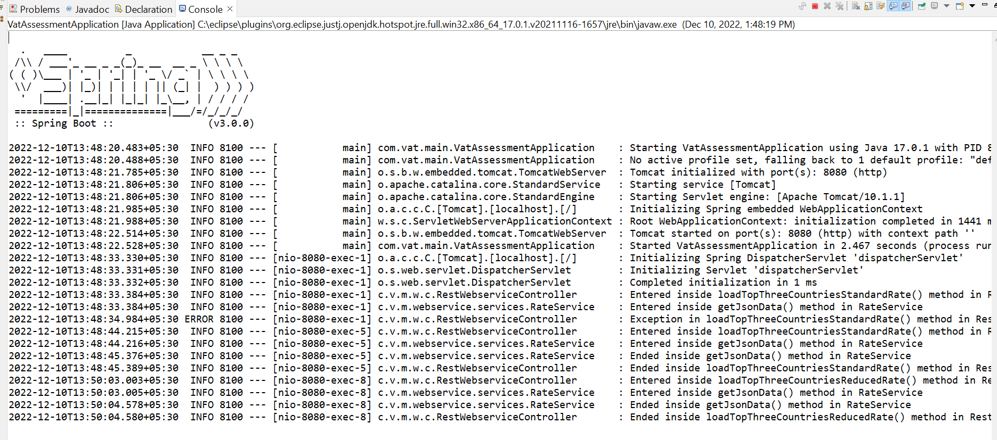

1. Use below URL's to test the assignment

[http://localhost:8080/api/vat/getStandardRates](http://localhost:8080/api/vat/standardrate)

[http://localhost:8080/api/vat/getReducedRates](http://localhost:8080/api/vat/reducedrate)

**Created Files for Assignments**

1. **Project Structure**

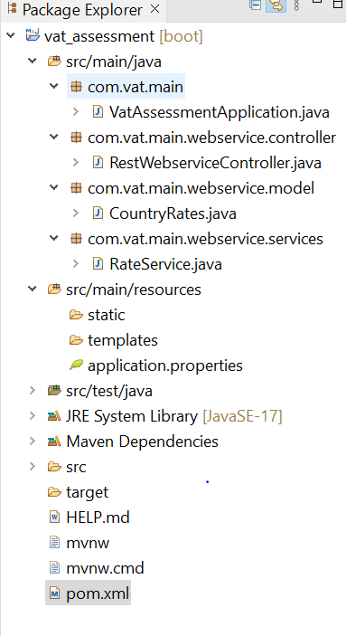

1. **Pom.xml** - Used to load dependencies
   1. **Spring-boot-starter-parent** – used to bootstrap the spring application
   2. **Spring-boot-starter-web** – used to start the web app and to support to make rest template call to the end point
   3. **Org.json** – Used to support object mapper to load the json data and to filter the json data by using json node

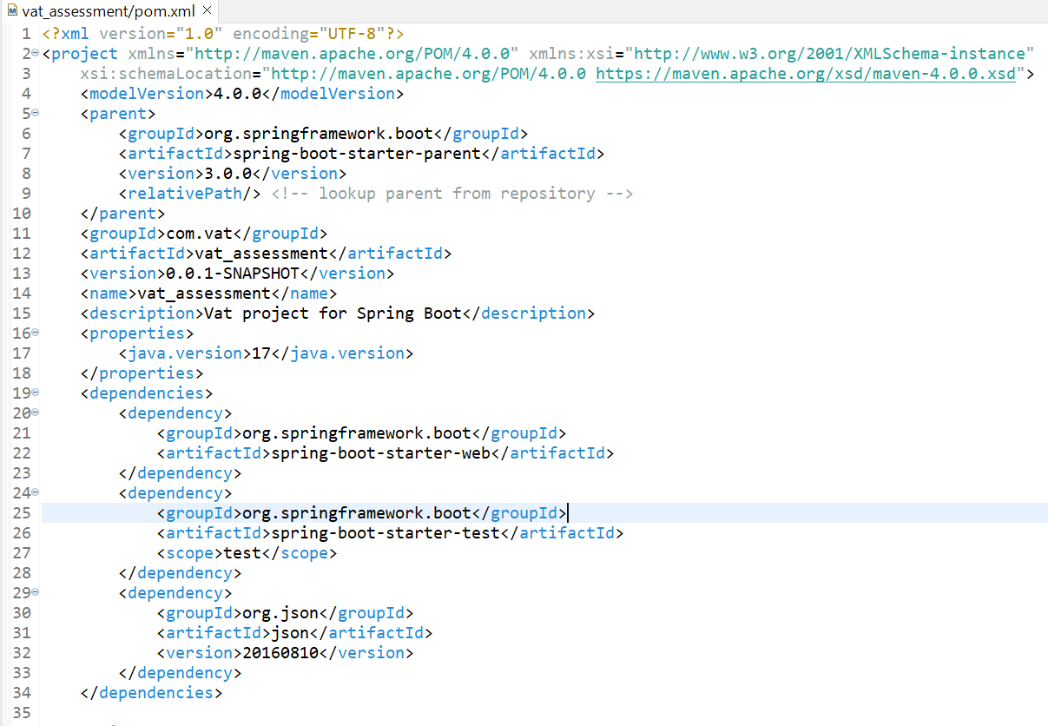

1. **Application.properties** – Used to maintain the endpoint as key/values and constant key values

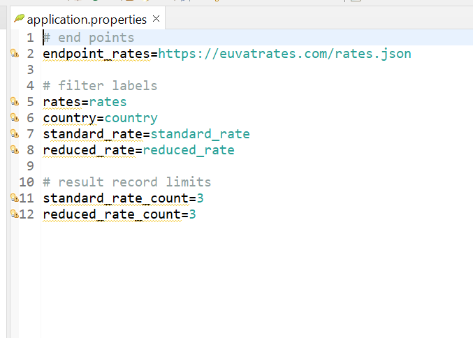

1. **VatAssessmentApplication.java** – Used to bootsrap the spring boot main class

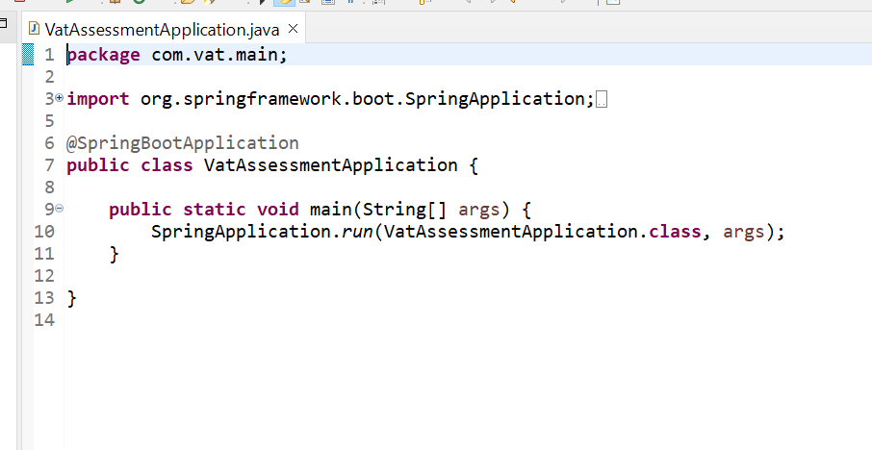

1. **CountryRates.java** – Used to maintain getter/setters in model bean class for the parameters Country, Standard Rate and Reduced Rate

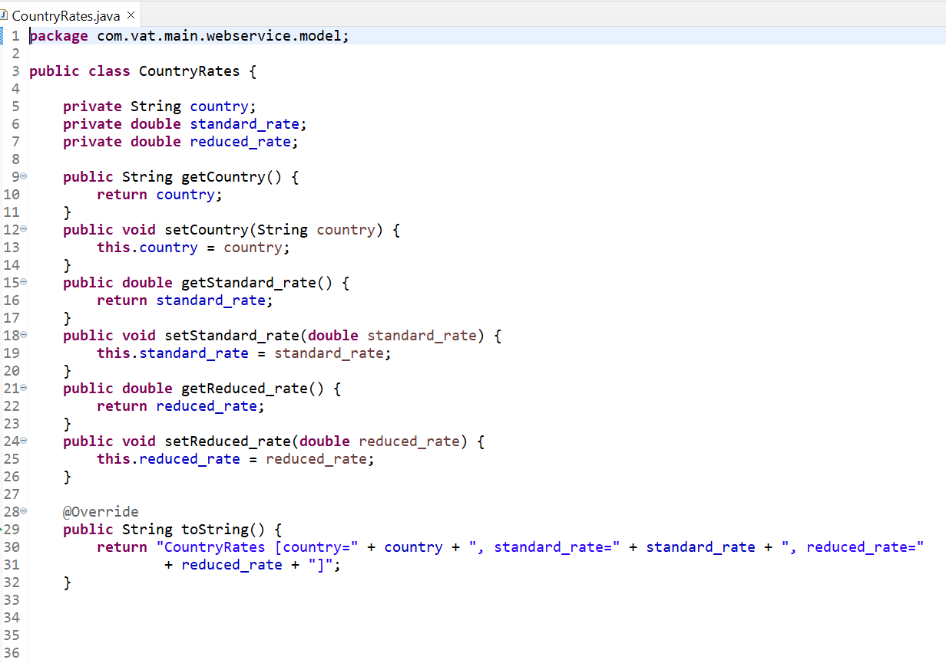

1. **VatRateController.java** – Used to invoke rate service to loa endpoint data and apply the filter logic as per requirements
   1. getStandardRateTopThreeCountries() method used to apply the requiremnt logic for top 3 countries highest standard vat rate
   2. getReducedRateTopThreeCountries() method used to apply the requirement logic for top 3 countries lowest reduced vat rate

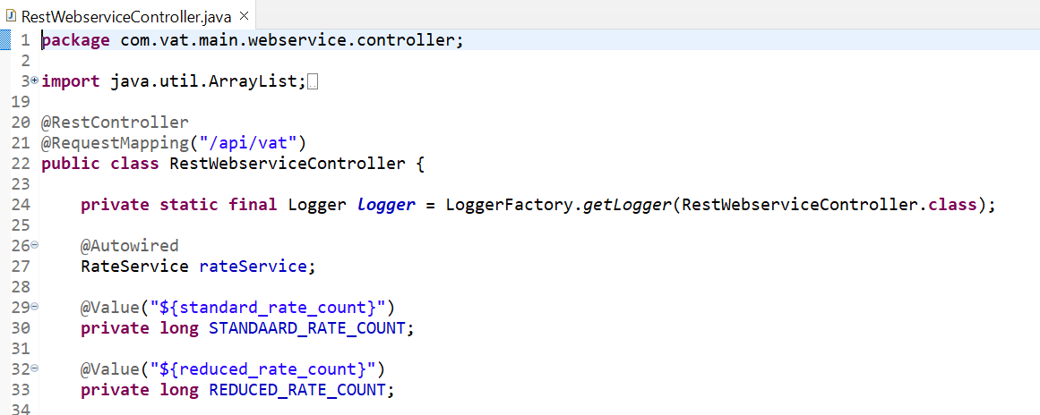

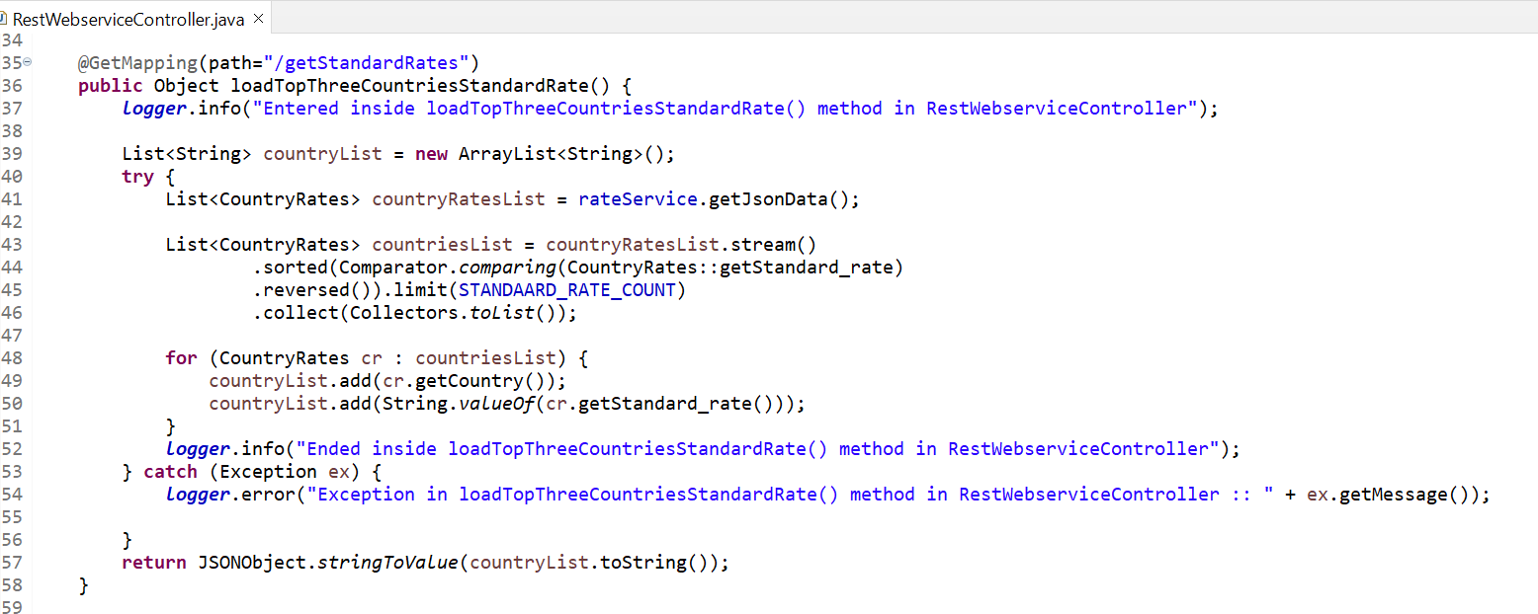

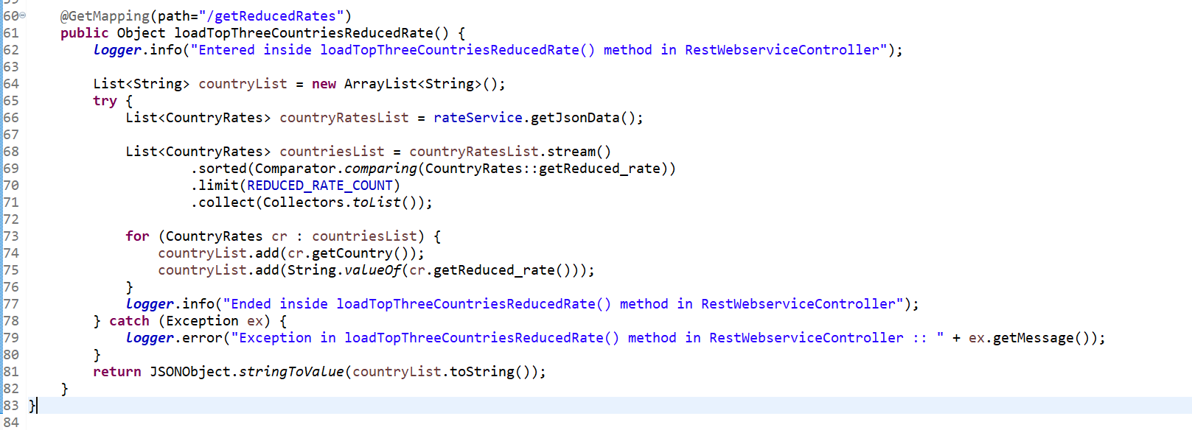

1. RestService.java – Used to make a rest service call using rest template to load the rates json data
   1. getJsonData() method used to load the json data from endpoint and filter the data based on requirement

